Nike Mockup: <https://github.com/ZOZO-coding/Dev/tree/main/MiniApp/nike>

Restaurant Objects Mockup: <https://github.com/ZOZO-coding/Dev/tree/main/Homeworks/week2/day2/restaurantMock>

Tokyo Bikes: <https://github.com/ZOZO-coding/Dev/tree/main/Homeworks/week2/tokyo-bikes>

StarWars Terminal Practice: <https://github.com/ZOZO-coding/Dev/tree/main/Labs/galaxy-far-far-away>

Hospital BootstrapMockup: <https://github.com/ZOZO-coding/Dev/tree/main/Homeworks/week3/bootstrap>

Movie Mockup: <https://github.com/ZOZO-coding/Dev/tree/main/Homeworks/week3/media_query>

My First Game: <https://github.com/ZOZO-coding/Dev/tree/main/MiniApp/tictactoe>

Flexbox Froggy Screnshot [1-12]:

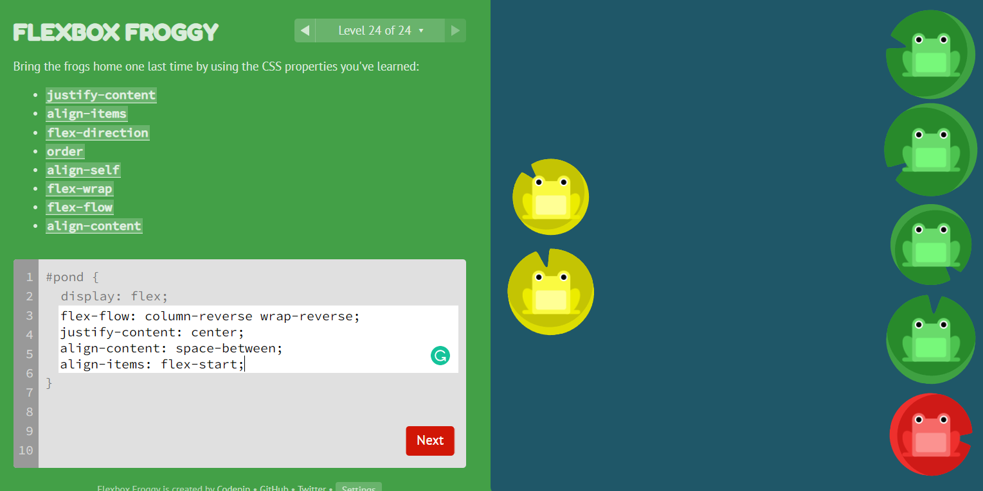

Dom Manipulation Assignment [3interactive elements]: <https://github.com/ZOZO-coding/Dev/tree/main/Homeworks/week4/dom_assignment>

Interactive Resume Mockup: <https://github.com/ZOZO-coding/interactiveResume>

Classes Exercise

Javascript Functions {maxOf2Nums}: <https://github.com/ZOZO-coding/Dev/blob/main/Homeworks/day4/day4hw_functions.js>

Javascript Total Recall {A.Q+A}: <https://github.com/ZOZO-coding/Dev/blob/master/labw3d1.js>

Space Battle: <https://github.com/ZOZO-coding/Dev/tree/main/MiniApp/battleship>

Radio Object: <https://github.com/ZOZO-coding/Dev/tree/main/Homeworks/week4/day4>